***Fruit Ninja***

***Game***

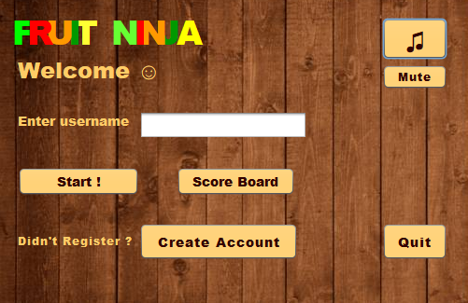

**Report Content**

1. Game Description
2. User Manual
3. Design Patterns
4. MVC
5. UML

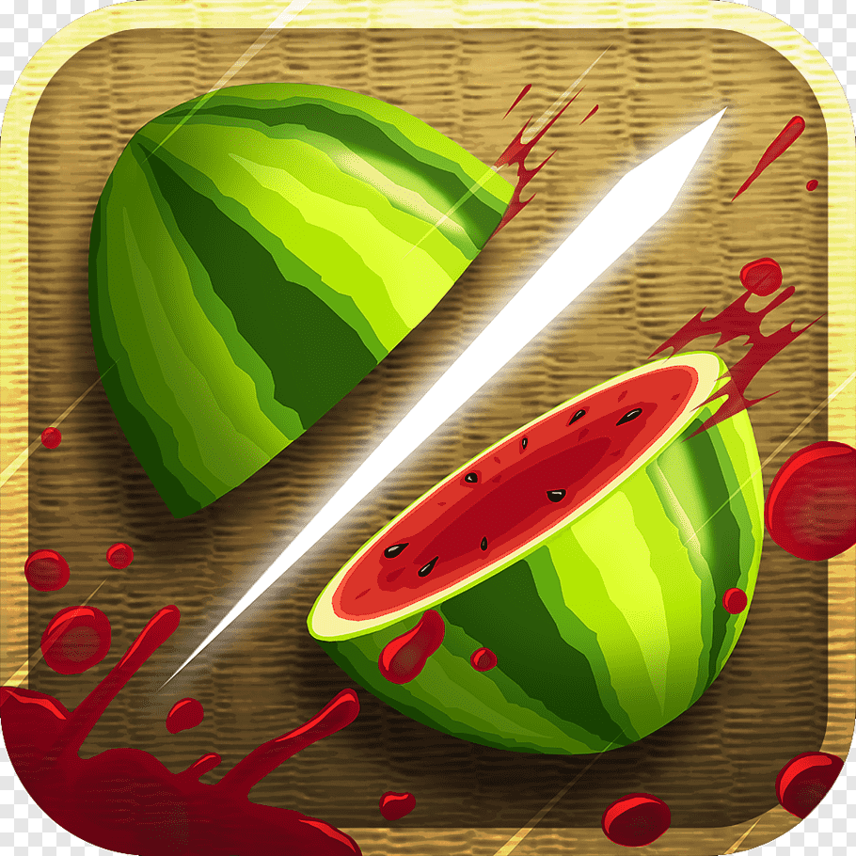

**Game Description**

Fruit Ninja is a classic game in which you find out how high your score is by playing classic mode in which you slice all the fruits that appear in front of you, calculate your total score and beat your own score but take care you slice a bomb. The game is supported with different music and is easy to use. Enjoy playing and have fun ☺.

**User Manual**

**First: Home Window**

When you open the game the home window appears and it contains the following:

1. A Text Field: To enter your account name.
2. A Start Button: To Start the game.
3. A Score Board Button: To view highscores of all players.
4. A Create Account Button: To create a new account.
5. A Play Music Button: To play the music of the game.
6. A Mute Music Button: To mute the music of the game.
7. A Quit Button: To exit the game.



**Second: Game Window**

* After you click the start button the game window appears and it contains:

1. A High Score Label: To display your high score.
2. A Score Label: To display your current score and it increases by slicing fruits during the game.
3. A Lives Label: To display your lives which decreases by slicing a bomb or if a fruit isnot sliced.
4. A Time Label: To display the time of playing the game.
5. A Play Music Button: To play the music of the game.
6. A Mute Music Button: To Mute the music of the game.

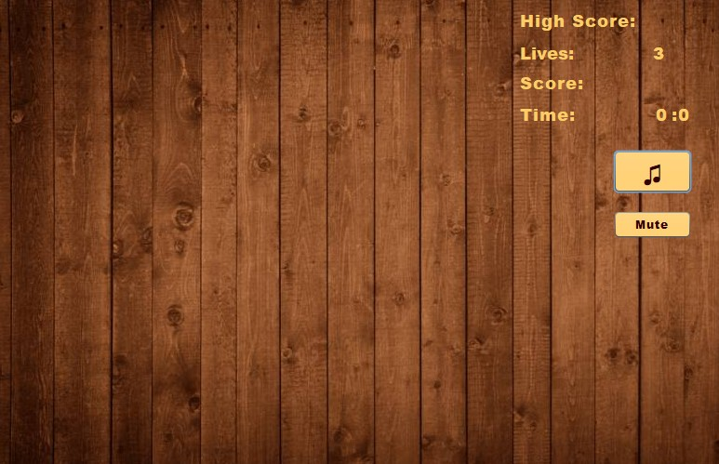

* While you play the game you will encounter different types of fruits like: Ordinary fruits and Special Fruits.

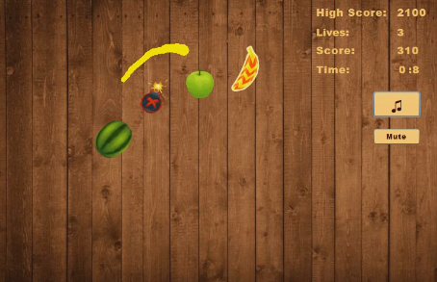

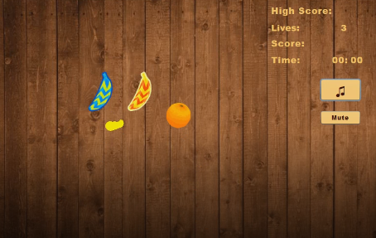

* When you slice ordinary fruits you gain score according to the type of fruit while if you slice a special fruit you gain score and its special effect like: Special Fruit one (Blue) which makes you gain one life and more score than the ordinary fruits.

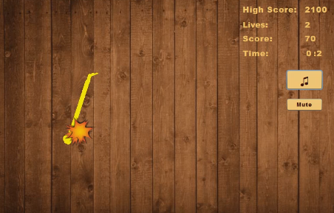

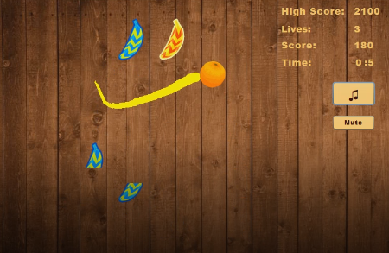

* Special Fruit two (Red) which makes you gain much higher score than any other fruit sliced.

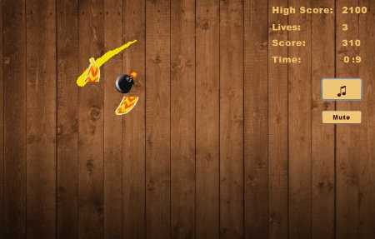

* There are two types of Bombs: Dangerous Bomb and Fatal Bomb.
* Fatal Bomb makes you lose the whole game and a Game Over Screen appears with your high score and the score you earned while playing if the score is less than your high score it says keep it up but if you beat your high score then it says new.

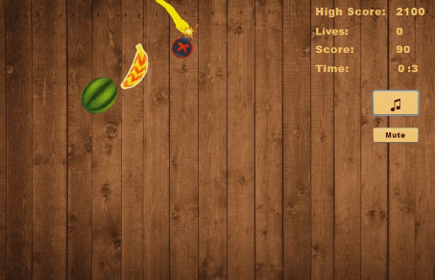

* Contains a Home Button which returns to home window.

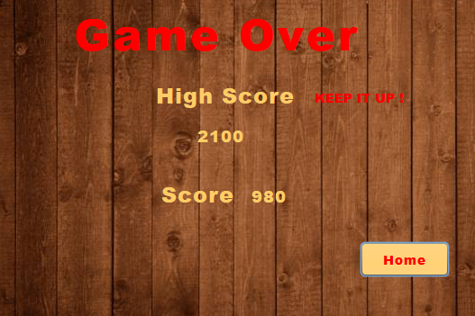

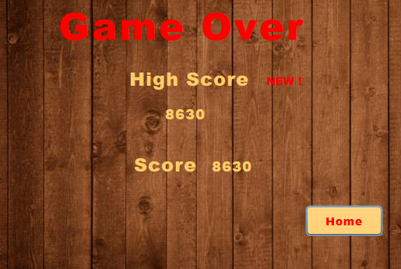

* Dangerous Bomb makes you lose one life.

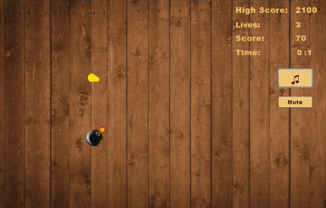



**Third: Create an Account Window**

When you press create account button a window appears which contains:

1. A Text Field: To enter the name of your account.
2. A Create Button: To create the account.
3. An Exit Button: To return to home window.

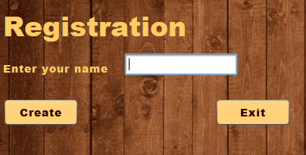

**Fourth: Score Board Window**

When you press Score Board Button a window appears which contains a table of all players with their high scores and a Home Button to return to home window.

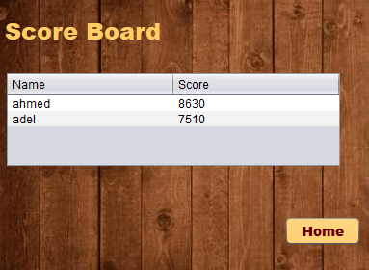

**Design Patterns**

The Design Patterns Used Are:

1. Singleton
2. Command
3. Observer
4. Factory
5. Decorator

**Singleton**

Singleton is used to create an instance of the object like player throughout the whole program without change and without creating more than one instance of the same object.

**Factory**

Factory is used to create the Fruits either special or ordinary and used to create Bombs

**Observer**

Observer is used to observe certain variables changes and also update them not in one class but in all classes which act as observers (observes certain object).

**Command**

Command is used to execute an action or more not in one class but throughout more than one class in which it is implemented.

**Decorator**

Decorator is used to increase the functionality of an object like the mouse drag in the game in which it does its function and have a different shape and color.

**Model View Controller (MVC)**

MVC is used to keep the separated components of a project into one unit separated to categories like a tree

**Model**

The Data and Business logic.

**View**

Displays the model and user can change this model in some cases.

**Controller**

It is the media between the model and the view where it allows data to flow between them.

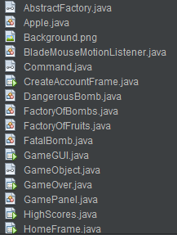

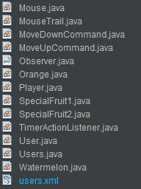

**UML**

**First: Class Diagram**

